**Spring REST using Spring Boot 3:**

**Exercise 1:** Create a Spring Web Project using Maven

**CODE:**

**pom.xml:**

<?xml version="1.0" encoding="UTF-8"?>

<project xmlns="http://maven.apache.org/POM/4.0.0" xmlns:xsi="http://www.w3.org/2001/XMLSchema-instance"

xsi:schemaLocation="http://maven.apache.org/POM/4.0.0 https://maven.apache.org/xsd/maven-4.0.0.xsd">

<modelVersion>4.0.0</modelVersion>

<parent>

<groupId>org.springframework.boot</groupId>

<artifactId>spring-boot-starter-parent</artifactId>

<version>3.5.3</version>

<relativePath/> <!-- lookup parent from repository -->

</parent>

<groupId>com.cognizant</groupId>

<artifactId>spring-learn</artifactId>

<version>0.0.1-SNAPSHOT</version>

<name>spring-learn</name>

<description>Demo project for Spring Boot</description>

<url/>

<licenses>

<license/>

</licenses>

<developers>

<developer/>

</developers>

<scm>

<connection/>

<developerConnection/>

<tag/>

<url/>

</scm>

<properties>

<java.version>21</java.version>

</properties>

<dependencies>

<dependency>

<groupId>org.springframework.boot</groupId>

<artifactId>spring-boot-starter-web</artifactId>

</dependency>

<dependency>

<groupId>org.springframework.boot</groupId>

<artifactId>spring-boot-devtools</artifactId>

<scope>runtime</scope>

<optional>true</optional>

</dependency>

<dependency>

<groupId>org.springframework.boot</groupId>

<artifactId>spring-boot-starter-test</artifactId>

<scope>test</scope>

</dependency>

</dependencies>

<build>

<plugins>

<plugin>

<groupId>org.springframework.boot</groupId>

<artifactId>spring-boot-maven-plugin</artifactId>

</plugin>

</plugins>

</build>

</project>

**Main Class:**

**SpringLearnApplication.java:**

package com.cognizant.spring_learn;

import org.springframework.boot.SpringApplication;

import org.springframework.boot.autoconfigure.SpringBootApplication;

@SpringBootApplication

public class SpringLearnApplication {

public static void main(String[] args) {

System.out.println("Spring Learn Application Started");

SpringApplication.run(SpringLearnApplication.class, args);

}

}

**Dependency Tree:**

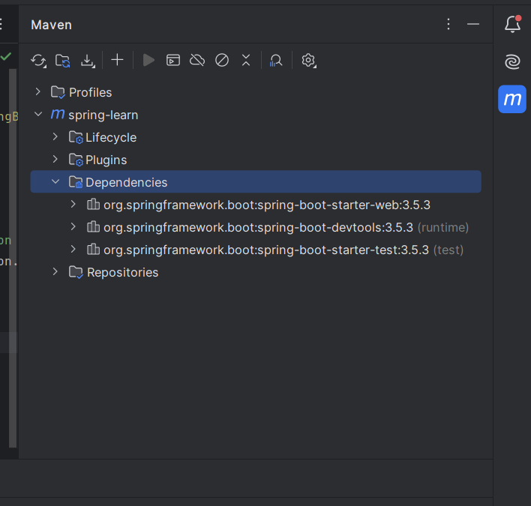

**OUTPUT:**

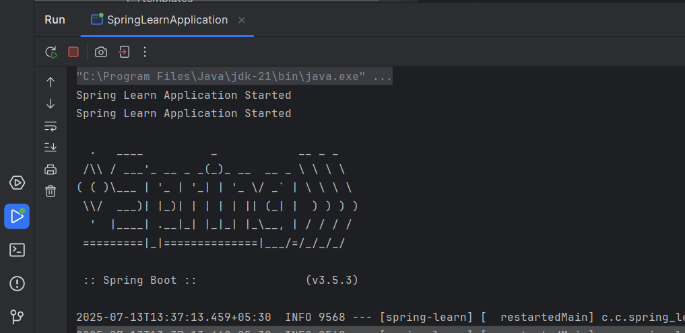

**Exercise 2:** Spring Core – Load Country from Spring Configuration XML

**CODE:  
pom.xml:**

<?xml version="1.0" encoding="UTF-8"?>

<project xmlns="http://maven.apache.org/POM/4.0.0"

xmlns:xsi="http://www.w3.org/2001/XMLSchema-instance"

xsi:schemaLocation="http://maven.apache.org/POM/4.0.0

http://maven.apache.org/xsd/maven-4.0.0.xsd">

<modelVersion>4.0.0</modelVersion>

<groupId>com.cognizant</groupId>

<artifactId>springlearn</artifactId>

<version>1.0-SNAPSHOT</version>

<properties>

<maven.compiler.source>21</maven.compiler.source>

<maven.compiler.target>21</maven.compiler.target>

<project.build.sourceEncoding>UTF-8</project.build.sourceEncoding>

</properties>

<dependencies>

<dependency>

<groupId>org.springframework</groupId>

<artifactId>spring-context</artifactId>

<version>5.3.32</version>

</dependency>

<dependency>

<groupId>org.slf4j</groupId>

<artifactId>slf4j-api</artifactId>

<version>1.7.36</version>

</dependency>

<dependency>

<groupId>org.slf4j</groupId>

<artifactId>slf4j-simple</artifactId>

<version>1.7.36</version>

</dependency>

</dependencies>

<build>

<plugins>

<plugin>

<groupId>org.apache.maven.plugins</groupId>

<artifactId>maven-compiler-plugin</artifactId>

<version>3.11.0</version>

<configuration>

<release>21</release>

</configuration>

</plugin>

</plugins>

</build>

</project>

**Country.xml:**

<?xml version="1.0" encoding="UTF-8"?>

<beans xmlns="http://www.springframework.org/schema/beans"

xmlns:xsi="http://www.w3.org/2001/XMLSchema-instance"

xsi:schemaLocation="http://www.springframework.org/schema/beans

https://www.springframework.org/schema/beans/spring-beans.xsd">

<bean id="country" class="com.cognizant.springlearn.Country">

<property name="code" value="IN" />

<property name="name" value="India" />

</bean>

</beans>

**Country.java:**

package com.cognizant.springlearn;

import org.slf4j.Logger;

import org.slf4j.LoggerFactory;

public class Country {

private static final Logger LOGGER = LoggerFactory.getLogger(Country.class);

private String code;

private String name;

public Country() {

LOGGER.debug("Inside Country Constructor.");

}

public String getCode() {

LOGGER.debug("Getting Code: {}", code);

return code;

}

public void setCode(String code) {

LOGGER.debug("Setting Code: {}", code);

this.code = code;

}

public String getName() {

LOGGER.debug("Getting Name: {}", name);

return name;

}

public void setName(String name) {

LOGGER.debug("Setting Name: {}", name);

this.name = name;

}

@Override

public String toString() {

return "Country{" +

"code='" + code + '\'' +

", name='" + name + '\'' +

'}';

}

}

**Main Class:**

**SpringLearnApplication.java:**

package com.cognizant.springlearn;

import org.slf4j.Logger;

import org.slf4j.LoggerFactory;

import org.springframework.context.ApplicationContext;

import org.springframework.context.support.ClassPathXmlApplicationContext;

public class SpringLearnApplication {

private static final Logger LOGGER = LoggerFactory.getLogger(SpringLearnApplication.class);

public static void main(String[] args) {

displayCountry();

}

public static void displayCountry() {

ApplicationContext context = new ClassPathXmlApplicationContext("country.xml");

Country country = context.getBean("country", Country.class);

LOGGER.debug("Country : {}", country.toString());

}

}

**OUTPUT:**

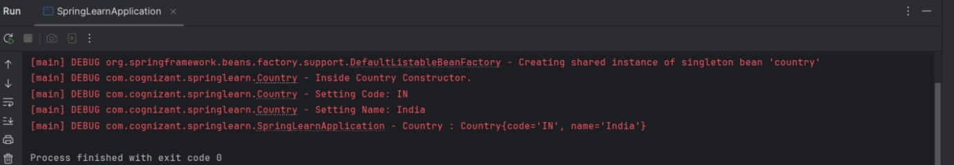

**Exercise 3**: Hello World RESTful Web Service

**CODE:  
Controller:**

**HelloController.java:**

package com.cognizant.spring_learn.controller;

import org.slf4j.Logger;

import org.slf4j.LoggerFactory;

import org.springframework.web.bind.annotation.GetMapping;

import org.springframework.web.bind.annotation.RestController;

@RestController

public class HelloController {

private static final Logger LOGGER = LoggerFactory.getLogger(HelloController.class);

@GetMapping("/hello")

public String sayHello() {

LOGGER.info("START sayHello()");

String message = "Hello World!!";

LOGGER.info("END sayHello()");

return message;

}

}

**Main Class:**

**SpringLearnApplication.java:**

package com.cognizant.spring_learn;

import org.springframework.boot.SpringApplication;

import org.springframework.boot.autoconfigure.SpringBootApplication;

@SpringBootApplication

public class SpringLearnApplication {

public static void main(String[] args) {

System.out.println("Spring Learn Application Started");

SpringApplication.run(SpringLearnApplication.class, args);

}

}

**Resources(application.properties):**

spring.application.name=spring-learn

server.port=8083

**OUTPUT:**



**Request:** <http://localhost:8083/hello>

**Response:**

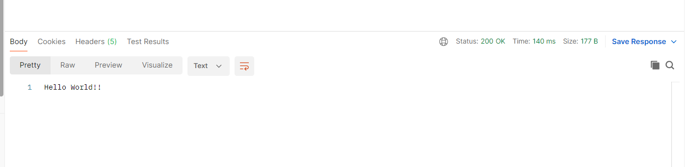

**Request and Response Header:** 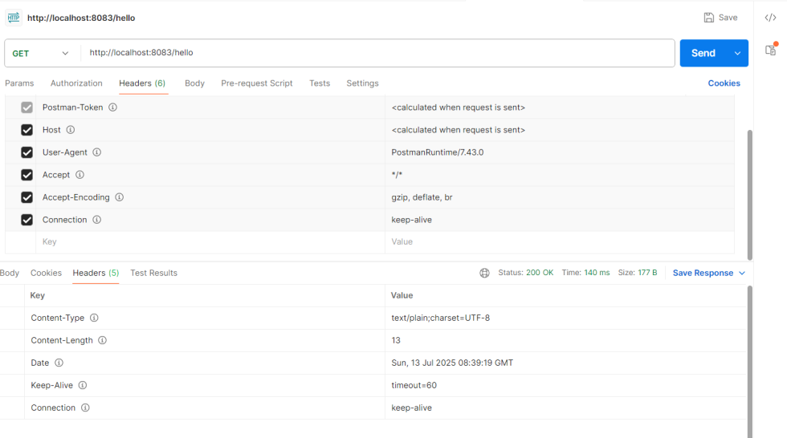

**Exercise 4:** REST - Country Web Service

**CODE:**

**Country.java:**

package com.cognizant.spring_learn.model;

public class Country {

private String code;

private String name;

public Country() {}

public Country(String code, String name) {

this.code = code;

this.name = name;

}

public String getCode() {

return code;

}

public void setCode(String code) {

this.code = code;

}

public String getName() {

return name;

}

public void setName(String name) {

this.name = name;

}

}

**Country.xml:**

<?xml version="1.0" encoding="UTF-8"?>

<beans xmlns="http://www.springframework.org/schema/beans"

xmlns:xsi="http://www.w3.org/2001/XMLSchema-instance"

xsi:schemaLocation="

http://www.springframework.org/schema/beans

https://www.springframework.org/schema/beans/spring-beans.xsd">

<bean id="in" class="com.cognizant.springlearn.model.Country">

<property name="code" value="IN"/>

<property name="name" value="India"/>

</bean>

</beans>

**Controller:**

**CountryController.java:**

package com.cognizant.springlearn.controller;

import com.cognizant.springlearn.model.Country;

import org.springframework.context.ApplicationContext;

import org.springframework.context.support.ClassPathXmlApplicationContext;

import org.springframework.web.bind.annotation.RequestMapping;

import org.springframework.web.bind.annotation.RestController;

@RestController

public class CountryController {

@RequestMapping("/country")

public Country getCountryIndia() {

ApplicationContext context = new ClassPathXmlApplicationContext("country.xml");

Country country = (Country) context.getBean("in");

return country;

}

}

**Main Class:**

**SpringLearnApplication.java:**

package com.cognizant.spring_learn;

import org.springframework.boot.SpringApplication;

import org.springframework.boot.autoconfigure.SpringBootApplication;

@SpringBootApplication

public class SpringLearnApplication {

public static void main(String[] args) {

System.out.println("Spring Learn Application Started");

SpringApplication.run(SpringLearnApplication.class, args);

}

}

**Resources(application.properties):**

spring.application.name=spring-learn

server.port=8083

**OUTPUT:**



**Request:** <http://localhost:8083/country>

**Response:**

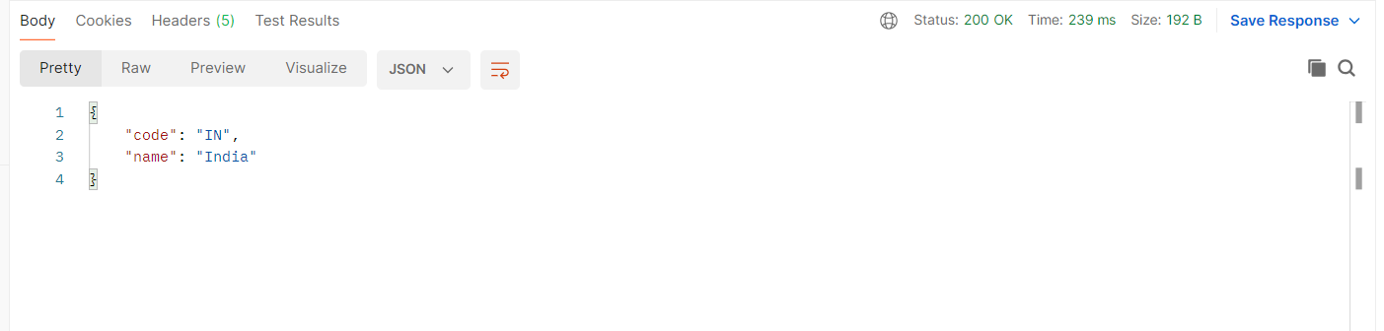

**Request and Response Header:**

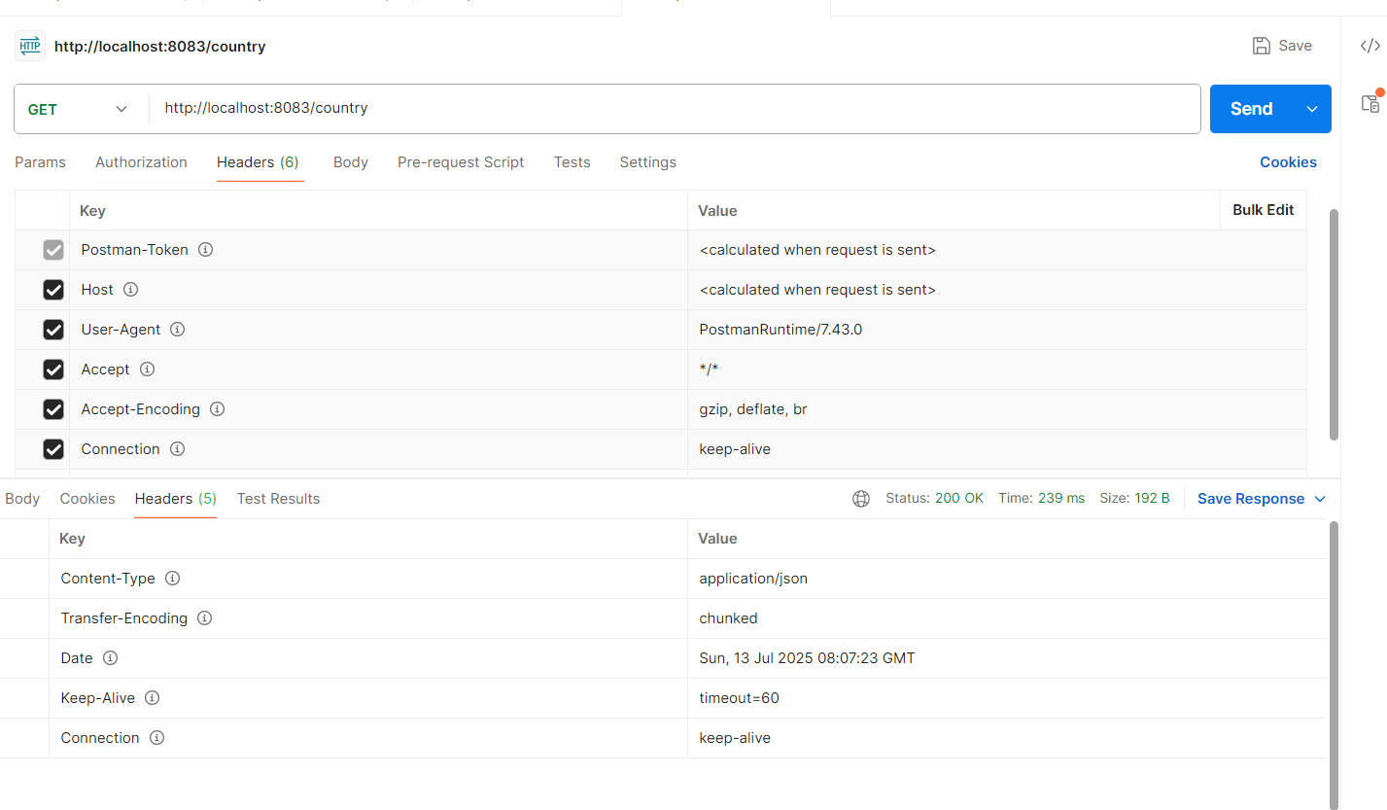

**Exercise 5:** REST - Get country based on country code

**CODE:**

**Country.xml:**

<?xml version="1.0" encoding="UTF-8"?>

<beans xmlns="http://www.springframework.org/schema/beans"

xmlns:xsi="http://www.w3.org/2001/XMLSchema-instance"

xsi:schemaLocation="

http://www.springframework.org/schema/beans

https://www.springframework.org/schema/beans/spring-beans.xsd">

<bean id="in" class="com.cognizant.spring_learn.model.Country">

<property name="code" value="IN"/>

<property name="name" value="India"/>

</bean>

<bean id="countryList" class="java.util.ArrayList">

<constructor-arg>

<list>

<bean class="com.cognizant.spring_learn.model.Country">

<property name="code" value="IN"/>

<property name="name" value="India"/>

</bean>

<bean class="com.cognizant.spring_learn.model.Country">

<property name="code" value="US"/>

<property name="name" value="United States"/>

</bean>

<bean class="com.cognizant.spring_learn.model.Country">

<property name="code" value="JP"/>

<property name="name" value="Japan"/>

</bean>

</list>

</constructor-arg>

</bean>

</beans>

**Service:**

**CountryService.java:**

package com.cognizant.spring_learn.service;

import com.cognizant.spring_learn.model.Country;

import org.springframework.context.ApplicationContext;

import org.springframework.context.support.ClassPathXmlApplicationContext;

import org.springframework.stereotype.Service;

import java.util.List;

@Service

public class CountryService {

public Country getCountry(String code) throws Exception {

ApplicationContext context = new ClassPathXmlApplicationContext("country.xml");

List<Country> countries = (List<Country>) context.getBean("countryList");

return countries.stream()

.filter(c -> c.getCode().equalsIgnoreCase(code))

.findFirst()

.orElseThrow(() -> new Exception("Country not found"));

}

}

**Controller:**

**CountryController.java:**

package com.cognizant.spring_learn.controller;

import com.cognizant.spring_learn.model.Country;

import org.springframework.context.ApplicationContext;

import org.springframework.context.support.ClassPathXmlApplicationContext;

import org.springframework.web.bind.annotation.RequestMapping;

import org.springframework.web.bind.annotation.RestController;

import org.springframework.beans.factory.annotation.Autowired;

import org.springframework.web.bind.annotation.GetMapping;

import org.springframework.web.bind.annotation.PathVariable;

import com.cognizant.spring_learn.service.CountryService;

import org.slf4j.Logger;

import org.slf4j.LoggerFactory;

@RestController

public class CountryController {

private static final Logger LOGGER = LoggerFactory.getLogger(CountryController.class);

@Autowired

private CountryService countryService;

@RequestMapping("/country")

public Country getCountryIndia() {

ApplicationContext context = new ClassPathXmlApplicationContext("country.xml");

Country country = (Country) context.getBean("in");

return country;

}

@GetMapping("/country/{code}")

public Country getCountry(@PathVariable String code) throws Exception {

LOGGER.info("Start getCountry: {}", code);

Country country = countryService.getCountry(code);

LOGGER.info("End getCountry");

return country;

}

}

**Country.java:**

package com.cognizant.spring_learn.model;

public class Country {

private String code;

private String name;

public Country() {}

public Country(String code, String name) {

this.code = code;

this.name = name;

}

public String getCode() {

return code;

}

public void setCode(String code) {

this.code = code;

}

public String getName() {

return name;

}

public void setName(String name) {

this.name = name;

}

}

**Main Class:**

**SpringLearnApplication.java:**

package com.cognizant.spring_learn;

import org.springframework.boot.SpringApplication;

import org.springframework.boot.autoconfigure.SpringBootApplication;

@SpringBootApplication

public class SpringLearnApplication {

public static void main(String[] args) {

System.out.println("Spring Learn Application Started");

SpringApplication.run(SpringLearnApplication.class, args);

}

}

**Resources(application.properties):**

spring.application.name=spring-learn

server.port=8083

**OUTPUT:**

  
**Request:** <http://localhost:8083/country/in>

**Response:**

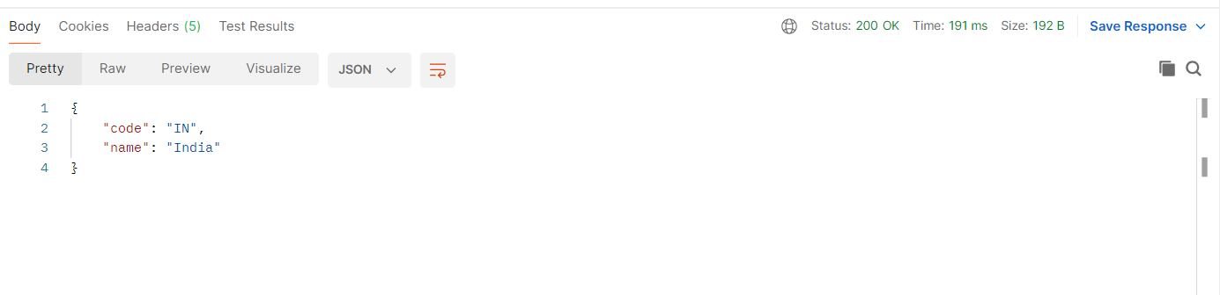

**Request and Response Header:**

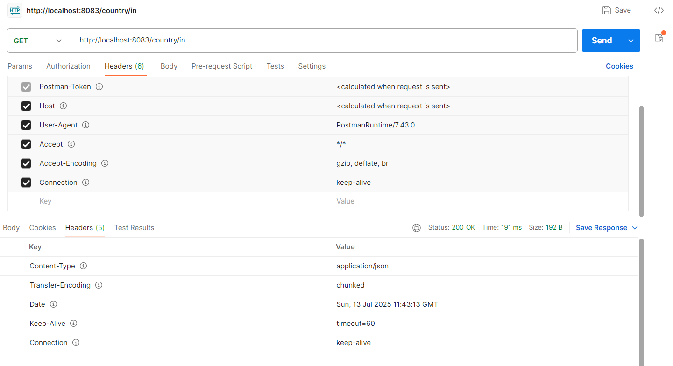

**Exercise 6**: Create authentication service that returns JWT

**CODE:**

**Pom.xml:**

<?xml version="1.0" encoding="UTF-8"?>

<project xmlns="http://maven.apache.org/POM/4.0.0" xmlns:xsi="http://www.w3.org/2001/XMLSchema-instance"

xsi:schemaLocation="http://maven.apache.org/POM/4.0.0 https://maven.apache.org/xsd/maven-4.0.0.xsd">

<modelVersion>4.0.0</modelVersion>

<parent>

<groupId>org.springframework.boot</groupId>

<artifactId>spring-boot-starter-parent</artifactId>

<version>3.5.3</version>

<relativePath/> <!-- lookup parent from repository -->

</parent>

<groupId>com.cognizant</groupId>

<artifactId>spring-learn</artifactId>

<version>0.0.1-SNAPSHOT</version>

<name>spring-learn</name>

<description>Demo project for Spring Boot</description>

<url/>

<licenses>

<license/>

</licenses>

<developers>

<developer/>

</developers>

<scm>

<connection/>

<developerConnection/>

<tag/>

<url/>

</scm>

<properties>

<java.version>21</java.version>

</properties>

<dependencies>

<dependency>

<groupId>org.springframework.boot</groupId>

<artifactId>spring-boot-starter-web</artifactId>

</dependency>

<dependency>

<groupId>org.springframework.boot</groupId>

<artifactId>spring-boot-devtools</artifactId>

<scope>runtime</scope>

<optional>true</optional>

</dependency>

<dependency>

<groupId>org.springframework.boot</groupId>

<artifactId>spring-boot-starter-test</artifactId>

<scope>test</scope>

</dependency>

<dependency>

<groupId>org.springframework.boot</groupId>

<artifactId>spring-boot-starter-security</artifactId>

</dependency>

<dependency>

<groupId>jakarta.servlet</groupId>

<artifactId>jakarta.servlet-api</artifactId>

<version>6.0.0</version>

<scope>provided</scope>

</dependency>

<dependency>

<groupId>io.jsonwebtoken</groupId>

<artifactId>jjwt-api</artifactId>

<version>0.11.5</version>

</dependency>

<dependency>

<groupId>io.jsonwebtoken</groupId>

<artifactId>jjwt-impl</artifactId>

<version>0.11.5</version>

<scope>runtime</scope>

</dependency>

<dependency>

<groupId>io.jsonwebtoken</groupId>

<artifactId>jjwt-jackson</artifactId>

<version>0.11.5</version>

<scope>runtime</scope>

</dependency>

</dependencies>

<build>

<plugins>

<plugin>

<groupId>org.springframework.boot</groupId>

<artifactId>spring-boot-maven-plugin</artifactId>

</plugin>

</plugins>

</build>

</project>

**Controller:**

**AuthenticationController.java:**

package com.cognizant.spring_learn.controller;

import com.cognizant.spring_learn.service.JwtUtil;

import jakarta.servlet.http.HttpServletRequest;

import org.springframework.http.ResponseEntity;

import org.springframework.web.bind.annotation.*;

import java.util.Base64;

import java.util.Collections;

@RestController

public class AuthenticationController {

@GetMapping("/authenticate")

public ResponseEntity<?> authenticate(HttpServletRequest request) {

System.out.println("authenticate() called"); // Debug print

String authHeader = request.getHeader("Authorization");

System.out.println("Authorization header: " + authHeader); // Debug print

if (authHeader != null && authHeader.startsWith("Basic ")) {

String base64Credentials = authHeader.substring("Basic ".length());

byte[] decodedBytes = Base64.getDecoder().decode(base64Credentials);

String decodedCredentials = new String(decodedBytes);

System.out.println("Decoded credentials: " + decodedCredentials); // Debug print

String[] userDetails = decodedCredentials.split(":", 2);

String username = userDetails[0];

String password = userDetails[1];

if (username.equals("user") && password.equals("pwd")) {

String token = JwtUtil.generateToken(username);

System.out.println("Token generated: " + token); // Debug print

return ResponseEntity.ok(Collections.singletonMap("token", token));

} else {

System.out.println("Invalid credentials");

return ResponseEntity.status(401).body("Invalid credentials");

}

}

System.out.println("Missing or incorrect Authorization header");

return ResponseEntity.badRequest().body("Missing Authorization header");

}

}

**Service:**

**JwtUtil.java:**

package com.cognizant.spring_learn.service;

import io.jsonwebtoken.Jwts;

import io.jsonwebtoken.SignatureAlgorithm;

import io.jsonwebtoken.security.Keys;

import java.security.Key;

import java.util.Date;

public class JwtUtil {

private static final Key key = Keys.secretKeyFor(SignatureAlgorithm.HS256);

public static String generateToken(String username) {

return Jwts.builder()

.setSubject(username)

.setIssuedAt(new Date())

.setExpiration(new Date(System.currentTimeMillis() + 1000 * 60 * 10)) // 10 minutes

.signWith(key)

.compact();

}

}

**Config:**

**SecurityConfig.java:**

package com.cognizant.spring_learn.config;

import org.springframework.context.annotation.Bean;

import org.springframework.context.annotation.Configuration;

import org.springframework.security.config.annotation.web.builders.HttpSecurity;

import org.springframework.security.web.SecurityFilterChain;

@Configuration

public class SecurityConfig {

@Bean

public SecurityFilterChain securityFilterChain(HttpSecurity http) throws Exception {

http

.csrf(csrf -> csrf.disable()) // Disable CSRF for testing

.authorizeHttpRequests(auth -> auth

.requestMatchers("/authenticate").permitAll()

.anyRequest().authenticated()

);

return http.build();

}

}

**Main Class:**

**SpringLearnApplication.java:**

package com.cognizant.spring_learn;

import org.springframework.boot.SpringApplication;

import org.springframework.boot.autoconfigure.SpringBootApplication;

@SpringBootApplication

public class SpringLearnApplication {

public static void main(String[] args) {

System.out.println("Spring Learn Application Started");

SpringApplication.run(SpringLearnApplication.class, args);

}

}

**Resources(application.properties):**

spring.application.name=spring-learn

server.port=8083

spring.devtools.restart.exclude=jjwt-impl-0.11.5.jar,jjwt-jackson-0.11.5.jar

**OUTPUT:(in Intellij IDEA)**

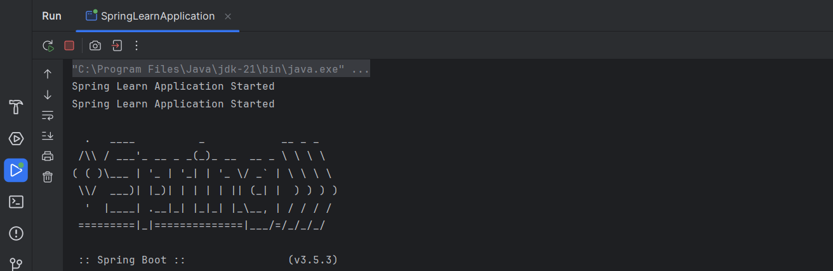

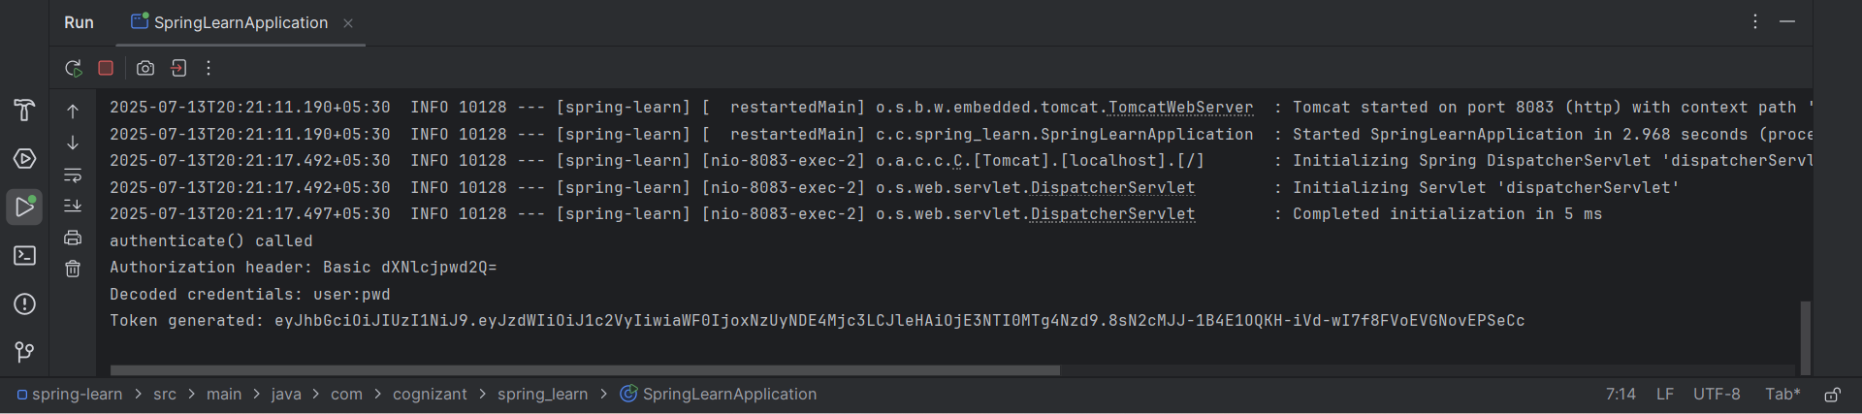

**OUTPUT:(In Postman)**

**Request:** http://localhost:8083/authenticate

